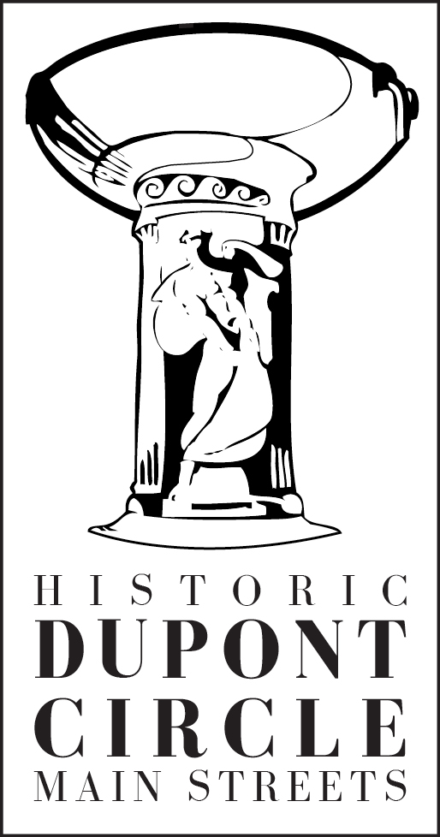
Storefront Improvement Grant Application

What is the Storefront Improvement Grant?
Dupont Circle Main Streets (HDCMS) is offering a matching grant to improve commercial building facades. In an effort to stimulate improvements to the appearance and atmosphere of the historic commercial district, HDCMS will reimburse successful grant applicants up to 50% of the cost for a storefront improvement, not to exceed $3,000 per building (1:1 match). The total cost of the restoration may exceed $6000, but no more than half (up to $3000) will be reimbursed.

Grants provided under this program are to be used for the materials and/or labor necessary in the conservation, preservation, restoration, or renovation of a commercial building along Dupont Circle’s commercial areas. Plans will be reviewed by the HDCMS Design Committee and then permitted by DCRA and the DC Historic Preservation Office since Dupont Circle lies within the Dupont Circle Historic District.

Who can apply for funding?
Building owners and tenants within the Dupont Circle commercial district, which includes P Street, Massachusetts Avenue, Connecticut Avenue, 18th Street, and 17th Street. Please refer to the HDCMS boundary map to see if a building is eligible to apply for participation in this program.

Eligible Projects Ineligible Projects
Signs Roof Repairs
Awnings Interior Improvements
Exterior Painting Electrical Work not related to Signs or Lighting
Repointing Stone and Brick Inappropriate Materials
Exterior Cleaning Sandblasting
Replacement of Transom Glass Temporary Window Displays
Removal of Non-Historic Materials Temporary Signs
Window Repair/Restoration
Repair/Restoration of Architectural Details

Are there design guidelines?
Projects must conform to District of Columbia zoning codes, Historic Preservation Office review, and the Dupont Circle Facade Design Guidelines. Projects must also meet the approval of the HDCMS Design Committee. The Design Committee and staff of HDCMS are available for consultation.

How are projects selected for funding?
Projects will be selected by the HDCMS Design Committee based on their adherence to the HDCMS Facade Design Guidelines and impact of the aesthetic on the building, and historic district as a whole. The Committee meets once a month, generally on the third Thursday of each month. Only completed applications will be reviewed by the Committee.

How is the money awarded?
The applicant is required to pay for the entire cost of the project up front. Following project completion, the HDCMS Design Committee will inspect the work to ensure compliance with the approved plan. After final project approval, the applicant is required to submit all receipts for material and labor costs and copies of all relevant permits. Reimbursement of up to 50% of the total cost of the project, maximum $3000 per building, will be made after final approval. A project started prior to a grant application approval is not eligible for funding. The Design Committee must approve any changes in the approved plans. Any unauthorized design changes may disqualify the applicant from the grant program.

How does the application process work?

- Applicants are encouraged to consult with the Design Committee prior to submitting the necessary permit application to the Department of Consumer and Regulatory Affairs (DCRA) and the Historic Preservation Office (HPO).

- Upon approval, the applicant will receive a letter of commitment from HDCMS for the specified amount with information on any other requirements, including the maximum timeframe for completion. The applicant may then proceed with necessary permits and city review processes. The HDCMS fiscal year ends September 30th of each year.

Is there a deadline for submitting an application?
Grant applications are accepted on a rolling basis, before July 30th, which provides two months for completion.

Applicants must satisfy the following procurement requirements:

- Fill out the grant application.

- Obtain a bid from a qualified contractor to rehabilitate historic buildings. The grant application must state the type and quantities of materials purchased and the total cost.

- Submit your application and necessary drawings, to the Dupont Circle Main Streets Design Committee for review.

- The HDCMS Design Committee will review the application at its regular meeting, until funds are expended.

- The Design Committee will notify the applicant of acceptance status and make any suggestions, as appropriate.

- Work permits from DCRA and the Historic Preservation Office will be needed to begin work.

- Once the project has been completed, a copy of all receipts must be submitted along with a copy of all work permits from DCRA. The Design Committee will inspect completed projects based on proposed work. After approval, applicants will be reimbursed for the pre-approved amount.
Grant Form:

Name of applicant: Date:

Name of business:
Address:

Phone: Fax: Email:
Applicant is the: ❏ property owner ❏ business owner ❏ other:

Property owner’s name, address, and phone number (if different from applicant):

Name: Business name:

Address:

City: State: Zip:

Phone: Fax: Email:

Proposed improvement:
Please provide a brief written description of the storefront improvement project:

Total cost: $ Grant amount: $ Proposed start date: Proposed completion date:

Attach a copy of a cost estimate from a contractor. Provide a cost breakdown by major category, such as paint, repointing, window restoration, labor, etc, and attach it to this application.

I, the undersigned, affirm that the information submitted herein is true and accurate to the best of my knowledge. I have read and understand the conditions of the HDCMS matching facade grant and agree to abide by its conditions and guidelines. The owner of the project building, if it is not me, is in agreement with this facade project.

Signature: Name: Date:

Grant Application Checklist:

__Completed grant form
__Contractor proposals with cost breakdown (materials and labor)
__Design of the storefront improvement

Send the completed grant application, along with attachments, to: Dupont Circle Main Streets; 9 Dupont Circle, NW; Washington DC 20036. Questions? Call (202) 656-4487 or email info@dupontcircle.biz.

